About us –

United Peace Foundation is a non-profit organization established to help and uplift the most vulnerable, orphans, destitute and widows regardless of faith race or creed.

**Address:** Zakir Nagar, Mango, Jamshedpur

**Phone**: +91 7463062868

**Email:** [unitedpeacefoundation@gmail.com](mailto:unitedpeacefoundation@gmail.com)

Our mission –

Many vulnerable orphans, abandoned children on the streets begging for survival need care and support.

**WHO WE** **ARE**

http://unitedpeacefoundation.in/images/line.png

We are a non-profit organization working to improve the life of orphans, widows, destitute and homeless children. We work across India especially rural areas and for the underprivileged section of the society to establish brotherhood, peace and unity among the people of different religion, caste and creed.

* Support orphans by providing food, education, medical assistance and other basic amenities.
* Sponsorship to orphans who are living with their mother / guardian by taking care of their monthly food and educational expenses.
* Provide monthly dietary assistance to widow headed families, destitute and helpless old age poor who are not capable of earning their bread.

### **OUR PROGRAMME**

http://unitedpeacefoundation.in/images/line.png

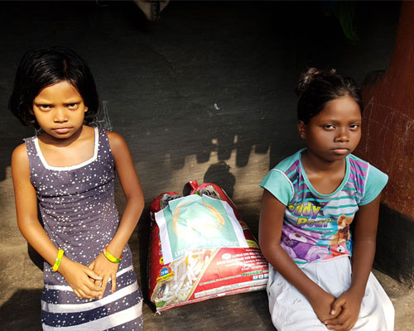

### **Orphan Sponsorship programme**

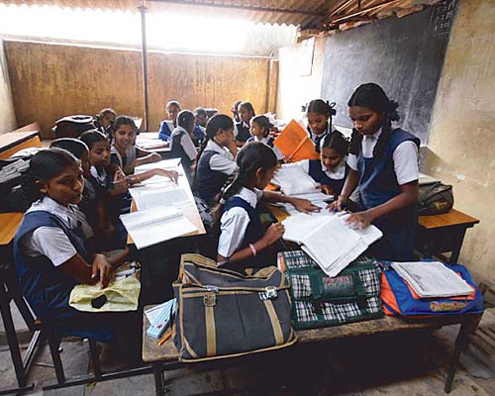

### **Educational programme**

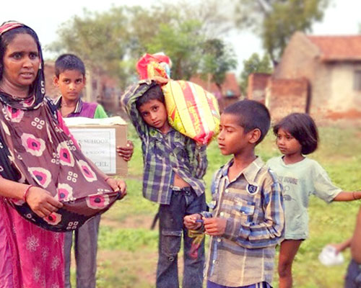

### **Food programme**



The coronavirus pandemic has taken the world by storm. It has not stopped United Peace foundation from distributing your aid to the most needy people so they can survive in this crisis. India is lockdown, the situation is extremely dire in the state of Jharkhand and millions of daily wage labours have been struggling to feed themselves and their families.

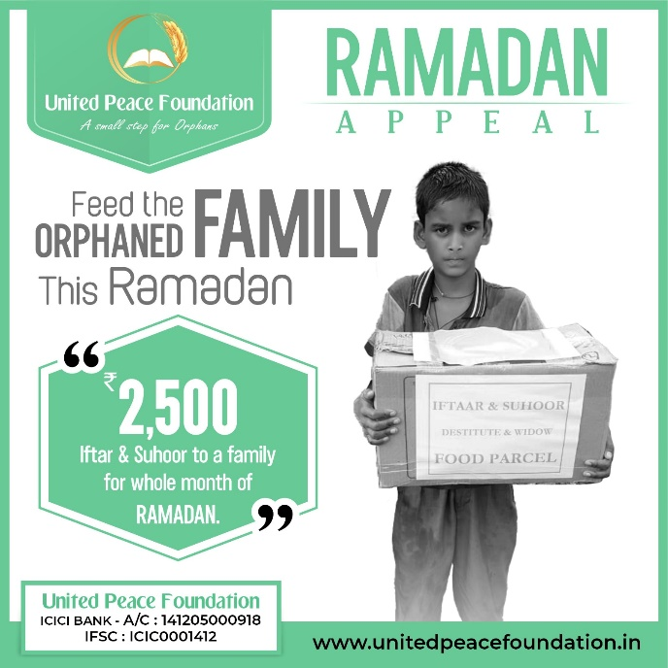

The Coronavirus pandemic has taken the world by storm. India is lockdown, markets are shut and the situation is not similar to past year Ramadan. Many more families need aid this Ramdan. Without YOUR support, many will sadly go hungry this Ramdan without Iftar or Suhoor. Show your generosity to your brothers and sisters at the time of crisis and feed a family for complete month of Ramadan.